**Active Directory installation steps:**

1. Open server manager and click on **Add Roles and Features** under Configure this local server

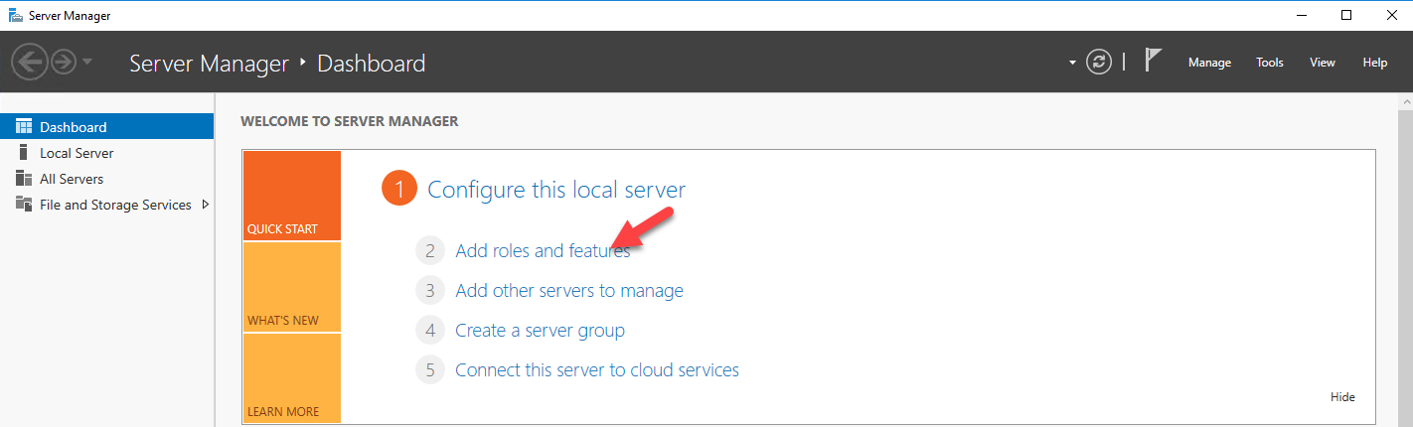

1. It then opens the add roles and features wizard. Click on **next** to proceed.

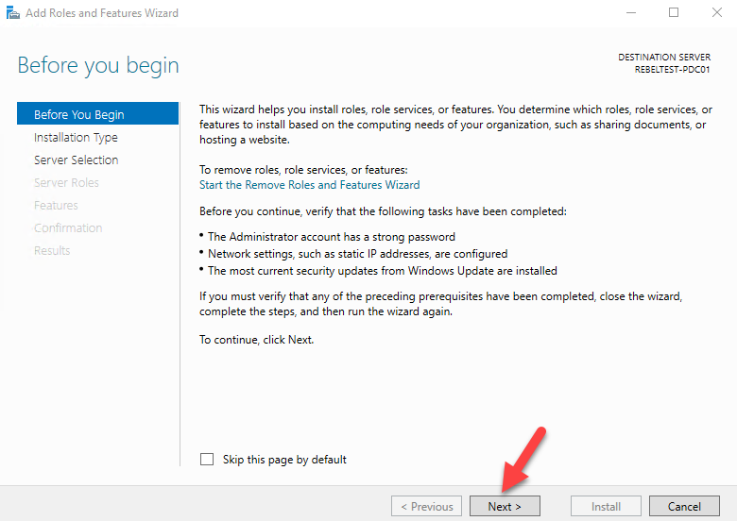

1. In next window keep the default - **Role Based or Feature based installation** and click **next.**

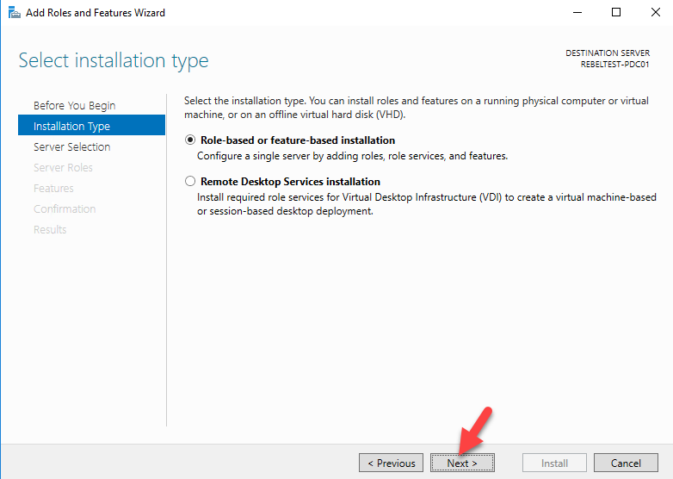

1. Since its going to be local server, in next window keep the default selection and hit **Next**

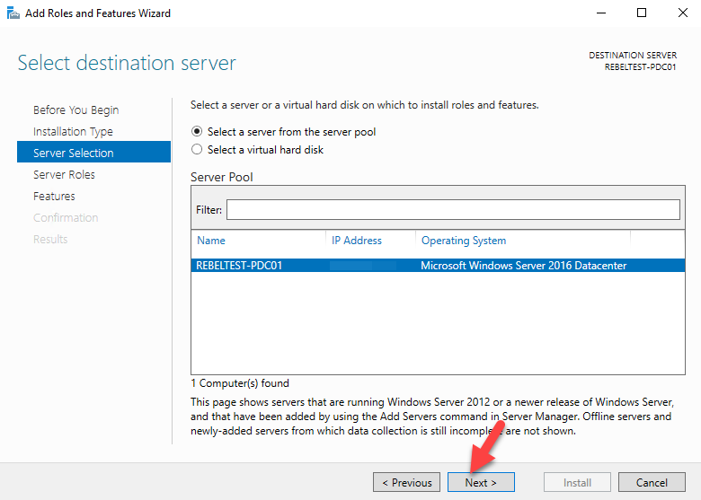

1. In next window from the roles put tick box for **Active Directory Domain Services**. Then it will prompt to show you what are the associated features for the role. Click on add features to add those. Then click **next** to continue.

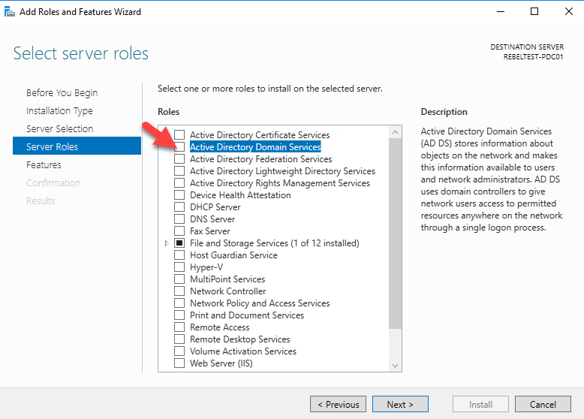

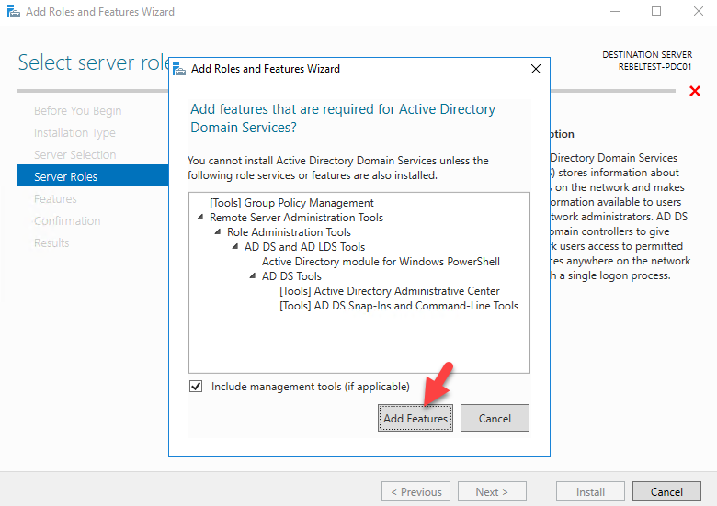

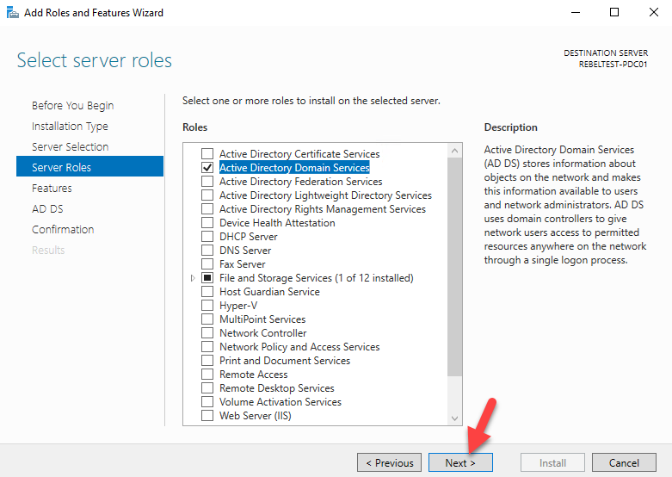

1. In the features page, keep it default and click on **next** to proceed.

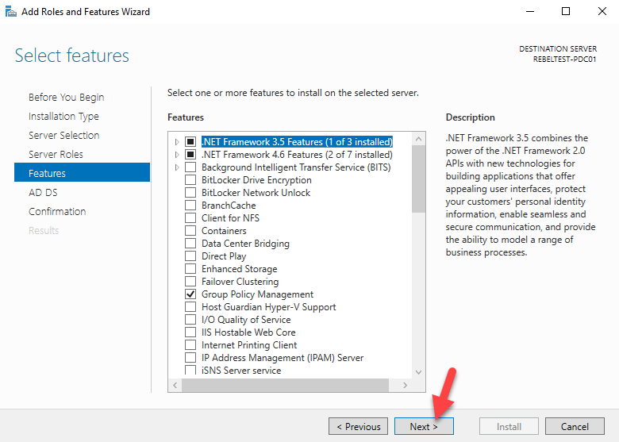

1. In next windows it gives brief description about AD DS service. Click **next** to proceed.

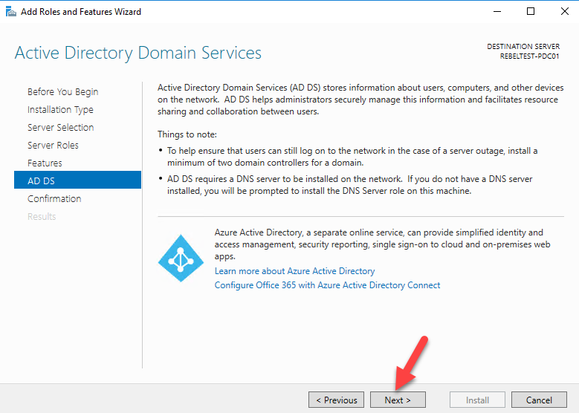

1. Then it will give the confirmation about install, click on **install** to start the role installation process.

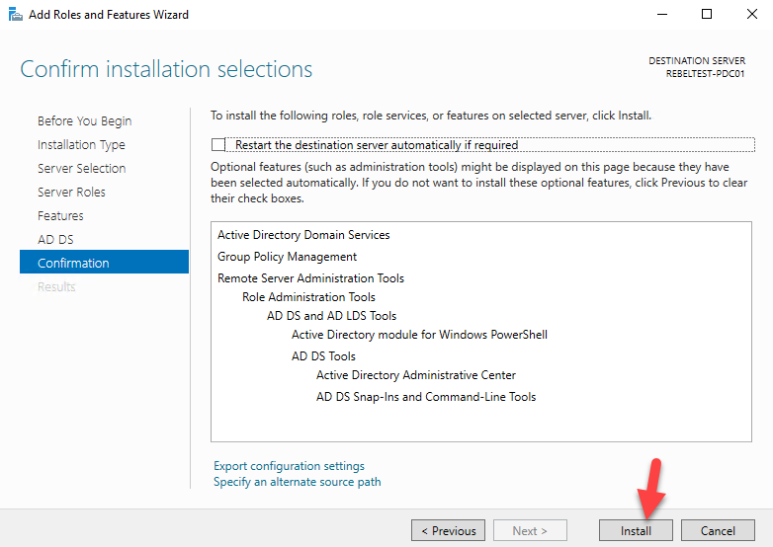

1. Once done, Installation process will begin.

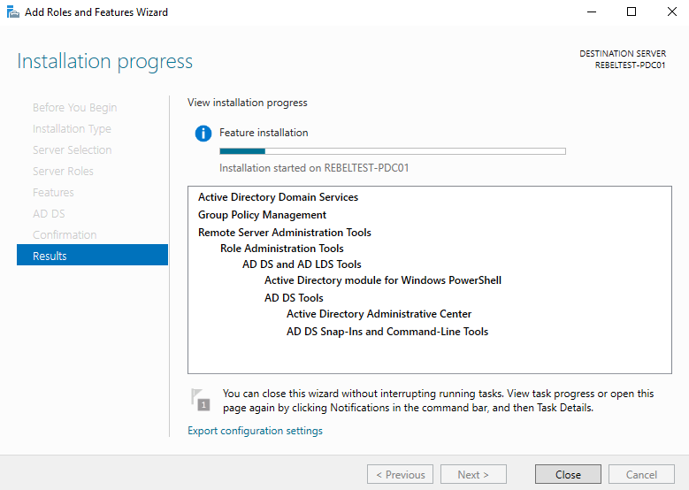

1. Once installation completes, click on option **promote this server to a domain controller.**

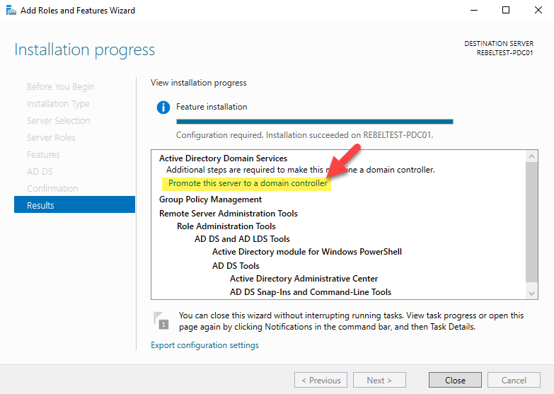

1. Then it will open the active directory configuration wizard. Here we are going to setup a new forest. But if you adding this to existing domain you can choose relevant option. Select the option to add new forest and type a name for the domain. Then click **next**.

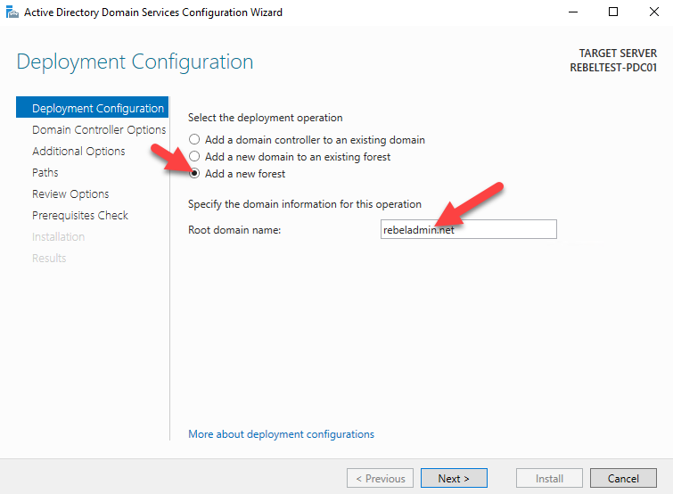

1. In next page you can select the domain and forest functional levels. I am going to set it up with latest. Then type a password for **DSRM**. Then click next

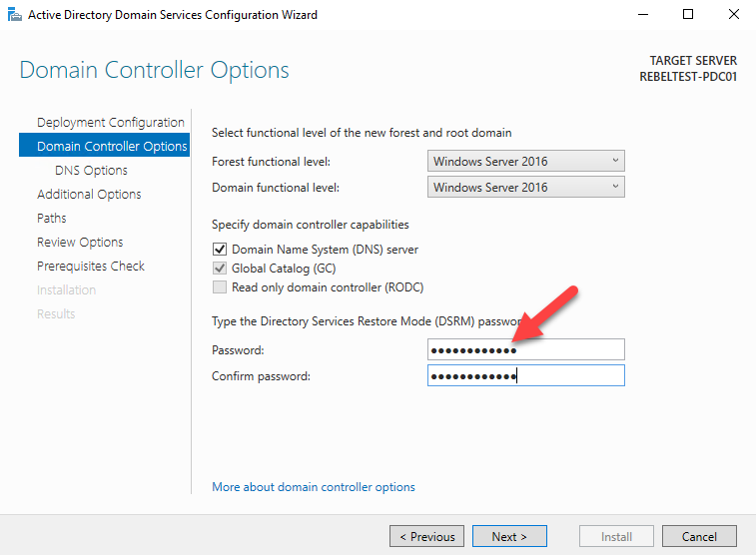

1. For the DNS options, this going to be the first DNS server in new forest. So no need any modifications. Click **next** to proceed

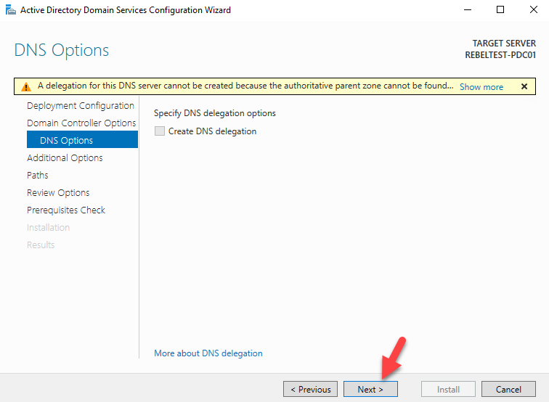

1. For the NETBIOS name keep the default and click **next**

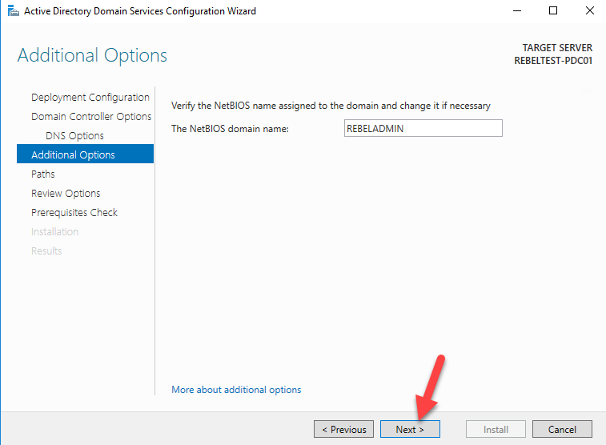

1. Next page is to define the **NTDS, SYSVOL** and **LOG** file folders. You can keep default and click **next** to continue

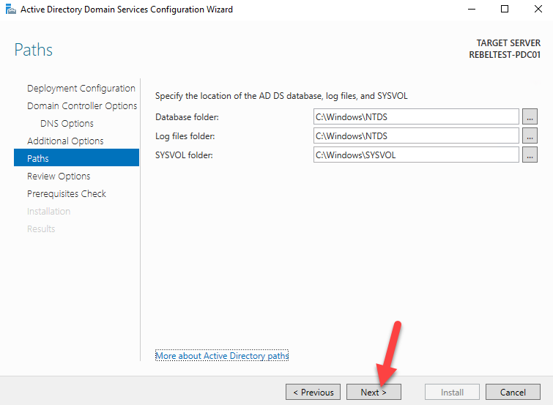

1. Next page will give option to review the configuration changes. If everything okay you can click **next** to proceed or otherwise can go back and change the settings.

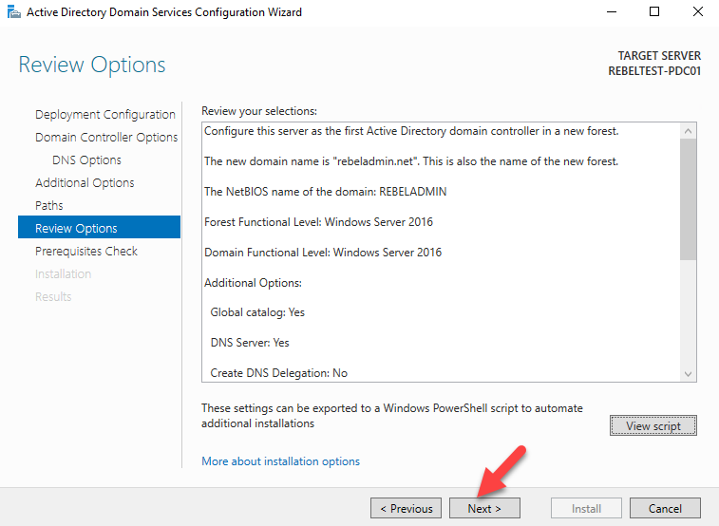

1. In next windows it will do prerequisite check. If it’s all good it will enable option to install. Click on **install** to begin installation process.

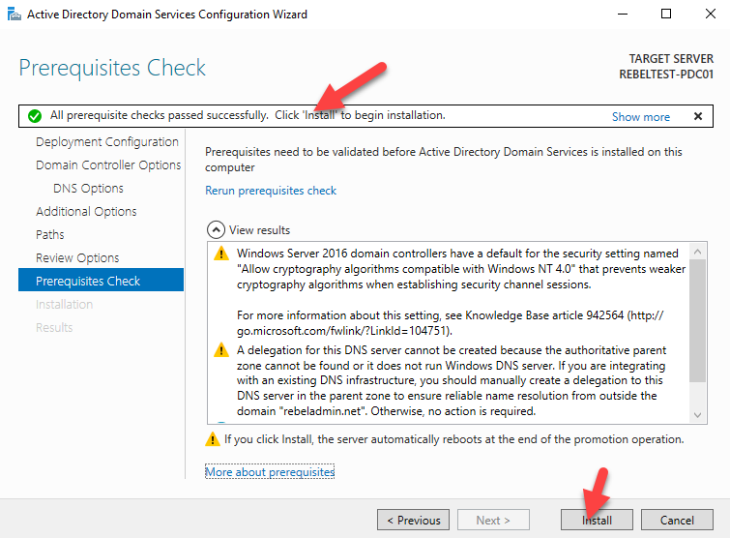

1. Then it will start the installation process.

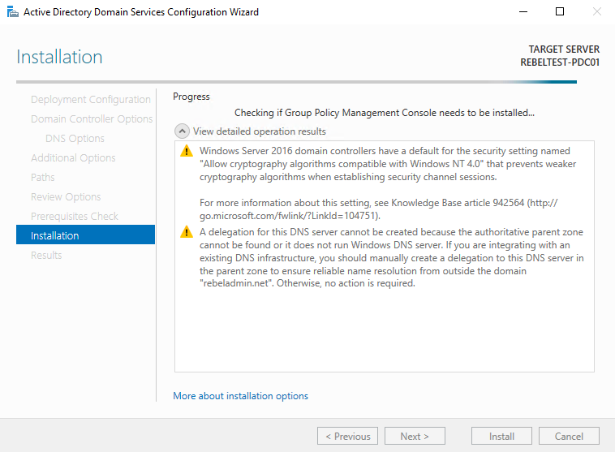

1. After the installation system will restart automatically. Once it comes back log in to the server as domain admin.



1. Once log in open the powershell (as administrator) and type **dsac.exe** and press **enter**. It will open up the active directory administrative center. There you can start managing the resources.

